Google Cloud Generative AI
Project Documentation
1. Introduction
Project Title:
Translingua: AI-Powered Multi-Language Translator
Team Members:
Team Leader : M S Dharani
Team member : Bommaka Nithin Kumar Reddy
Team member : Bn Pavan
Team member : C Guruprasad

2. Project Overview
Purpose
The purpose of Translingua is to develop a full-stack web application that enables users to translate text from one language to another using Artificial Intelligence. The system aims to eliminate communication barriers and provide fast, reliable, and accurate translations.
The project demonstrates the integration of MERN stack technologies with AI-powered translation APIs.
Features
- Multi-language text translation
- User-friendly interface
- Real-time translation output
- Copy translated text feature
- Responsive design
- Secure backend API handling
- Scalable architecture
3. Architecture
Frontend (React.js)
The frontend of the application is developed using React.js. It provides a dynamic and responsive user interface.
Key components include:
- Language Selection Dropdown
- Text Input Area
- Translate Button
- Output Display Section
React Hooks such as useState and useEffect are used to manage state and handle API calls.
Backend (Node.js & Express.js)
The backend is built using Node.js and Express.js. It acts as a middleware between the frontend and the AI translation API.
Responsibilities:
- Receiving translation requests
- Validating input data
- Calling external translation API
- Sending response back to frontend
- Error handling
RESTful APIs are implemented for communication.
Database (MongoDB)
MongoDB is used to store:
- User translation history
- User details (if authentication enabled)
- Logs and analytics
Collections include:
- users
- translations
The backend interacts with MongoDB using Mongoose.
4. Setup Instructions
Prerequisites
- Node.js (v14 or higher)
- MongoDB installed or MongoDB Atlas account
- npm (Node Package Manager)
- Git
Installation
Step 1: Clone the repository
git clone
Step 2: Navigate to project folder
cd translingua
Step 3: Install backend dependencies
cd server
npm install
Step 4: Install frontend dependencies
cd client
npm install
Step 5: Configure environment variables
Create a .env file in server folder and add:
MONGO_URI=your_mongodb_connection_string
API_KEY=your_translation_api_key
PORT=5000
5. Folder Structure
Client (React Frontend)
client/
│── public/
│── src/
│ │── components/
│ │── App.js
│ │── index.js
│── package.json
The client folder contains React components and UI logic.

Server (Node.js Backend)
server/
│── controllers/
│── routes/
│── models/
│── server.js
│── package.json
The server folder manages API routes, business logic, and database interaction.
6. Running the Application
Start Backend
cd server
npm start
Start Frontend
cd client
npm start
Frontend runs on: http://localhost:3000
Backend runs on: http://localhost:5000
7. API Documentation
1. Translate Text
Endpoint: /api/translate
Method: POST
Request Body:
{
"text": "Hello",
"sourceLang": "en",
"targetLang": "es"
}
Response:
{
"translatedText": "Hola"
}
8. Authentication
Authentication is implemented using JSON Web Tokens (JWT).
Process:
- User registers/login
- Server generates JWT token
- Token stored in local storage
- Token sent in Authorization header for protected routes
Middleware verifies token before granting access.
9. User Interface
The UI consists of:
- Language selection dropdown
- Text input box
- Translate button
- Output display box
- Copy button
The design is responsive and works across devices.
(Insert screenshots here in Word document)
10. Testing
Testing Strategy:
- Manual Testing
- API Testing using Postman
- Functional Testing for translation accuracy
- UI Testing for responsiveness
Tools Used:
- Postman
- Browser Developer Tools
11. Screenshots or Demo
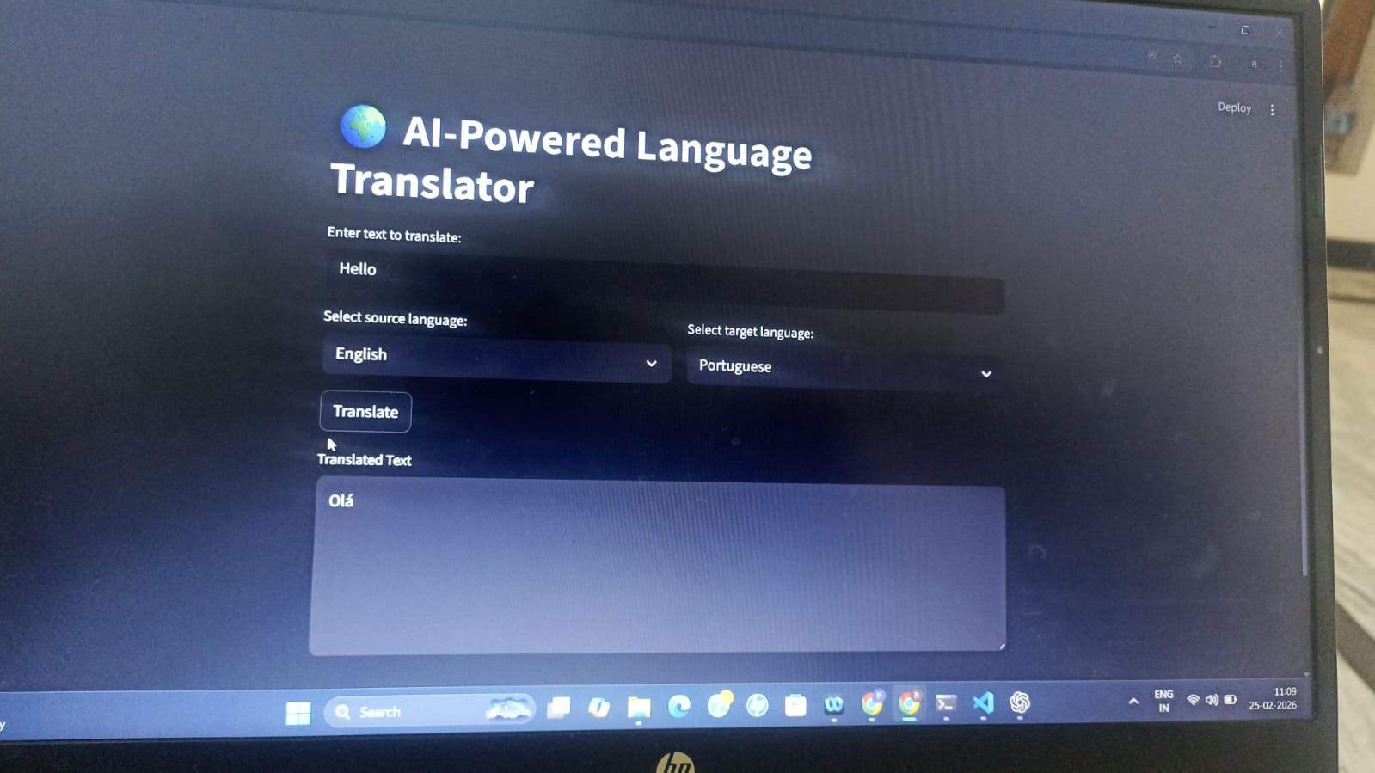
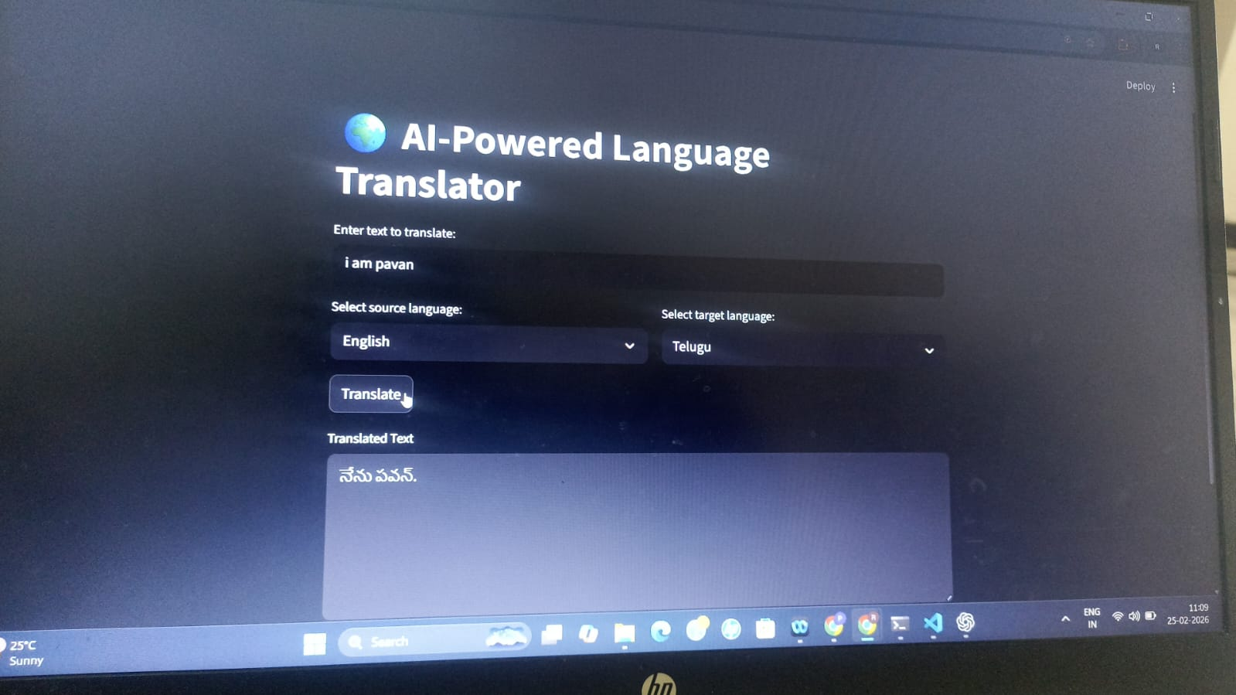
Example:
GitHub: https://github.com/bnpavankalyan2004/translingua
Demo:
12. Known Issues
- Minor contextual translation errors
- API rate limits
- Internet dependency
- Large text may slightly increase response time
13. Future Enhancements
- Voice-to-text translation
- Offline translation mode
- Mobile application version
- AI-based contextual understanding
- Chat-based real-time translation

